Biocalc at Illinois

J. Jerry Uhl, Department of Mathematics, University of Illinois-Urbana
Judy Holdener, Department of Mathematics, Kenyon College

Abstract

BioCalc is a Mathematica-driven calculus course for life science students. It has been taught at the University of Illinois since the fall of 1993. In this article we describe how the course came to be, how it is structured, and how it differs from other calculus courses. We also provide a sample of the electronic notebooks used in the course. Finally, we report on some of BioCalc’s successes.

Course Structure

- Weeks per term: 15-week semester
- Classes per week/type/length: One or two 1-hour lecture periods
- Labs per week/length: Three or four 1-hour laboratory periods
- Average class size: Sections are capped at 20.
- Enrollment requirements: First-year students in the biological sciences. Students cannot enroll unless they are life science majors.
- Faculty/dept per class, TAs: Typically taught by a graduate TA in mathematics or sometimes a faculty member. There is also one undergraduate class assistant.
- Next course: Life science majors must take two of Calculus I, Calculus II, and Statistics, so some continue on to Calculus II.
- Website: http://www-cm.math.uiuc.edu/

Introduction

In the late 1980s at Illinois, our Illinois-Ohio State group developed a Mathematica-based calculus course now offered at Illinois. By the early 1990s, the Mathematica-based calculus sequence Calculus & Mathematica (C&M) (Uhl et al., 2006) had been class-tested and revised. In this revision, we decided to place heavy emphasis on life science models because our vision of calculus had become that it is the study and measurement of growth. This led the way to an emphasis on teaching calculus with life science models. After all, what grows? Animals, populations, and epidemics do. As our course evolved, we could see that many students from a variety of fields, including engineering, identified better with the life science models than they did with the physics examples that are typically used in a calculus course. At that point a fortuitous event occurred…

Professor Sandra Lazarowitz of the School of Life Sciences at Illinois called one of us and said that the standard calculus course was not connecting with the life science students, who were not interested in computing the work done by a force or the position of a projectile. The engineering emphasis in calculus sent the signal that it had little to do with their future careers in the biological sciences. As evidence of the disconnect, Professor Lazarowitz said that approximately 60% of the life science majors enrolled in the traditional Calculus I course were receiving a grade of C or lower in the course. It is a common misconception that life science students are weak in mathematics. We told her we were working on a calculus course that might be better suited for her life science students.

In the fall of 1993, two Calculus & Mathematica sections were reserved for life science students. The pilot sections were small (approximately 16 students each) and were taught by graduate teaching assistants Judy Holdener and Bill Hammock in a computer lab located within the Life Sciences building. The ACT scores of the students suggested that they would be at risk in traditional calculus, and many of the students had a high degree of math phobia. Despite these disadvantages, the students flourished in the experimental C&M sections. Professor Lazarowitz, who was also the Director of the Howard Hughes Program for Undergraduate Education in the Life Sciences at Illinois, happily reported “first year life science students [in Calculus & Mathematica sections] are studying mathematical models normally reserved for senior math majors, and student responses have been enthusiastic.” She was encouraged by the success rate, reporting that life science students who would likely have dropped a traditional offering of calculus were able to earn As with the new approach. As a result of the success of the pilot sections, the Department of Mathematics and the School of Life Sciences entered into an agreement to call the course “BioCalc” and to make it a permanent offering for life science students.

After seventeen years, life science students continue to flourish in BioCalc. Using university records, staff at the Howard Hughes Medical Institute assessed the course in April of 2001 and cited the following conclusions in their report on the course (Fahrbach et al., 2001):

- The BioCalc course is equally attractive to life sciences students required to take Math 120 (the standard calculus course at Illinois). No life sciences option is over- or underrepresented.
- BioCalc students are as well prepared for Math 130 (the second calculus course in the standardsequence) as non-BioCalc students, as judged by the grade obtained in Math 130.
- BioCalc students are roughly twice as likely to take an additional math course than non-BioCalc students.
- BioCalc students (80.4%) are slightly more likely to remain in a biological science major than non-BioCalc students (76.7%).
- CalcPrime successfully prepares for BioCalc those students who do not place into Math 120.

The Differences between BioCalc and the Standard Calculus Course

So what is it that makes BioCalc so different from the traditional offering of calculus? Here are some differences:

Greater emphasis on applications and life science models in particular.

One of the biggest reasons for the success of BioCalc is its emphasis on life science models that reveal the relevance of calculus and reinforce the meaning of the derivative. There are exercises examining the decay of cocaine in the blood, models describing the spread of a disease, and data analyses investigating the correlation between cigarette smoking and lung cancer. Students examine data relating to the U.S. and world populations, the U.S. national debt, and the number of a space shuttle’s O-ring failures. They compute the optimal speed of a salmon swimming up a river, and they model the growth rates of an animal’s height and weight over time. (See the next section.) In BioCalc, life science students get enough experience to see for themselves that calculus plays a role in their lives and in their planned careers. One BioCalc student put it this way: "What we learned applies in our classes and in our lives."

Greater emphasis on visualization.

The authors of the electronic notebooks used in BioCalc have gone to great lengths to help the student learn visually. The “textbook” is a sequence of interactive electronic notebooks that introduce new ideas using graphic examples and geometric interpretations. By working through the notebooks, students experience mathematics at their own pace by seeing it happen and making it happen. The graphics offered by Mathematica allow students to create the mental images necessary to understand calculus—images that students won’t always be able to create for themselves.

Less emphasis on mathematical language and proof but more emphasis on conceptual explanation.

Students in introductory calculus sometimes find the language of mathematics (i.e., the symbols and technical terminology) to be impenetrable, but among life science students the language barrier tends to be endemic. BioCalc circumvents the problem by using graphics and applications as the entry points for new material. Formal definitions and notation are introduced only after students internalize the ideas. Because most introductory calculus students will not choose careers involving the writing of mathematical proofs, BioCalc places a lesser emphasis on the writing of formal proofs and a greater emphasis on the use of calculus as a tool for solving problems.

Greater emphasis on writing and communication.

Although BioCalc places less emphasis on the writing of formal proofs, it places on a greater emphasis on writing. The electronic notebooks include numerous exercises that require students to describe what they see on the computer screen and to analyze what is happening. The students use their own words, and the writing solidifies their understanding of the material.

Studying the comprehensive group of models offered by BioCalc is possible only because of the computational and graphical power offered by Mathematica. Students regard Mathematica as a professional tool, and they are delighted to use it because most of them arrived in BioCalc knowing their hand computation skills were not at the level required for success in a standard calculus course.

The Format of BioCalc

So how are the BioCalc lessons structured and what exactly do students do in and out of class? The “textbook” is electronic, consisting of a series of interactive Mathematica notebooks, and students learn calculus by working through tutorial problems, experimenting with built-in Mathematica routines, and explaining graphical and computational output. Each lesson follows the same format, with four components:

- The Basics section introduces the fundamental ideas in the lesson by presenting problems and explanations, often visual in nature. Students are encouraged to experiment with the problems by changing functions and numbers and rerunning the Mathematica code. Many of the problems prompt students to make conjectures about the patterns they observe in the computer output.
- The Tutorial section, like the Basics section, presents problems for the student, but the focus is on techniques and applications that relate to the ideas presented in the Basics section.
- The Give it a Try section is the heart of the course, providing a list of problems to be solved and submitted (electronically) by the student. Like the Tutorial section, problems are often application-based, incorporating models from the life sciences. Information needed to solve the problems is found in the Basics and Tutorial sections.
- The Literacy Sheets present problems to be worked out with paper and pencil. This section is completed after the student has already completed the electronic portions of the lesson.

Although the format may vary with the instructor, most BioCalc lessons are conducted in a computer lab. On a typical lab day, students work through the electronic notebooks at their own pace, asking questions of the instructor as needed. On every third or fourth session, the class meets in a standard classroom for a traditional chalkboard discussion. Students are graded on the electronic work they complete (in the Give it a Try section of the lesson) and the written work they do on the Literacy Sheets. Exams generally have both a written component and a computer component.

BioCalc Sampler

In this final section, we reveal the flavor of BioCalc’s electronic lessons by examining BioCalc’s coverage of the chain rule. The chain rule is often associated with hand computation in calculus, but BioCalc students learn it in parallel with constructing height and weight functions to model the growth of animals over time. We will illustrate below, starting with the first mention of the chain rule. (Incidentally, BioCalc does not allow students to rely on the computer for the computation of derivatives, among other things. A basic literacy is expected of the students.)

In introducing the chain rule, the Basics section starts by encouraging students to look for patterns in the derivatives of compositions of functions. What follows is taken directly from the electronic notebook covering the differentiation rules. Mathematica syntax is in bold (the code has not been executed).
----
B.2) The chain rule: D[f[g[x]],x]=(f′)[g[x]] (g′)[x]

Let's check out the derivative of the composition of two functions.
Here is the derivative of Sin[x^2]:

Clear[f,x];
f[x_]=Sin[x^2]; (f′)[x]

Or

D[Sin[x^2], x]

This catches your eye because the derivative of Sin[x] is Cos[x] and the derivative of x^2 is 2x. It seems that the derivative of Sin[x^2] is manufactured from the derivative of Sin[x] and the derivative of x^2. Here is the derivative of (x^2+ Sin[x])^8:

D[(x^2+Sin[x])^8, x]

This catches your eye because the derivative of x^8 is 8 x^7 and the derivative of x^2+ Sin[x] is 2x+ Cos[x]. It seems that the derivative of (x^2+ Sin[x])^8 is manufactured from the derivative of x^8, the derivative of Sin[x], and the derivative of x^2.
Here is the derivative of f[g[x]]:

Clear[f,g]; D[f[g[x]],x]

Very interesting and of undeniable importance. This formula, which says that the derivative of h[x]=f[g[x]] is h'[x]=f'[g[x]] g'[x], is called the chain rule. Do a check:

Clear[f,g,x];
D[f[g[x]], x]==f'[g[x]]g'[x]

The chain rule tells you how to build the derivative of f[g[x]] from the derivatives of f[x] and g[x]. Here is the chain rule in action:
If h[x]=Sin[x^2], then h'[x]=Cos[x^2] 2 x in accordance with:

D[Sin[x^2], x]

And if h[x]=(x^2+ Sin[x])^8, then h'[x]=(8 (x^2+ Sin[x]))^7 (2 x+ Cos[x]) in accordance with:

D[(x^2+Sin[x])^8, x]

B.2.a) Give an explanation of why the derivative of f[g[x]] is f'[g[x]] g'[x].

Answer: Put h[x]=f[g[x]].
Recall that h[x] grows h'[x] times as fast as x.
But
- f[g[x]] grows f'[g[x]] times as fast as g[x]
- g[x] grows g'[x] times as fast as x.
As a result, f[g[x]] grows f'[g[x]] g'[x] times as fast as x.
This explains why the instantaneous growth rate of f[g[x]] is f'[g[x]] g'[x].
In other words, the derivative of f[g[x]] with respect to x is f'[g[x]] g'[x].
This rule is called the chain rule, and it is important.
----

After presenting this explanation of the chain rule, the Basics section continues with more examples, presenting the derivatives of sin(5x), sin(x⁴), (g(x))³, f(x³y²) (with respect to y), and (e^{x} – x²)⁷.

Later in the Tutorial section, the students examine the effects of scaling on surface area and volume and use the chain rule to explain why the instantaneous percentage growth rate of the weight of a Bernese Mountain Dog is three times the instantaneous percentage growth rate of the height. In the excerpt of the electronic textbook that follows, the only Mathematica output included are the plots. The rest of the output is excluded for the sake of space.
----

T.3) Linear dimension: length, area, volume and weight

The volume measurement, V[r], and the surface area measurement, S[r], of a sphere of radius r are given by
V[r]= (4 \[Pi] r^3)/3
S[r]= 4 \[Pi] r^2.
This says that V[r] is proportional to r^3 and S[r] is proportional to r^2.
For other three-dimensional objects, the formulas for volume and surface area are not so easy to come by, but the idea of proportionality survives. Here is the idea: A linear dimension of a given solid or shape is any length between specified locations on the solid. The radius of a sphere or the radius of a circle is a linear dimension. The total length of a solid, the total width, and the total height of a solid are examples of linear dimensions. The diameter of the finger loop on a coffee cup is a linear dimension of the cup.

Next take a given shape for a solid. If it stays the same but the linear dimensions change, then it is still true that the volume is proportional to the cube of any linear dimension and it is still true that the surface area is proportional to the square of any linear dimension.

Here is a shape in the x-y plane and the same shape with its linear dimensions increased by a factor of 3:

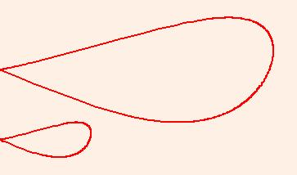

T.3.a) How does the area measurement of the larger blob above compare to the area measurement of the smaller blob?

Answer: Both are the same shape, but the linear dimensions of the larger blob are three times the linear dimensions of the smaller blob. The upshot: The area measurement of the larger blob is 3^2=9 times the area of the smaller blob.

T.3.b) The idea of linear dimension leads to some intriguing biological implications. A giant mouse with linear dimension ten times larger than the usual mouse would not be viable because the volume of its body would be larger than the volume of the usual mouse by a factor of 10^3, but the surface area of some of its critical supporting organs like lungs, intestines and skin would be larger only by a factor of 10^2. That big mouse would be hungry and out of breath at all times! Similarly, there will never be a 12-foot-tall basketball player at Indiana or even at Duke. The approximate size of an adult mammal is dictated by its shape! The same common sense applies to buildings and other structures. An architect or engineer does not design a 200-foot-tall building by taking a design for a 20-foot-tall building and multiplying all the linear dimensions by 10.
Now it's time for a calculation.

A crystal grows in such a way that all the linear dimensions increase by 25%. How do the new surface area and new volume compare to the old surface area and volume?

Answer:

Clear[newsurfacearea,oldsurfacearea];
newsurfacearea = 1.25^2 oldsurfacearea

An increase of the linear dimensions by 25% increases the surface area by about 56%.
The percentage increase in volume is:

Clear[newvolume,oldvolume];
newvolume = 1.25^3 oldvolume

An increase of the linear dimensions by 25% increases the volume by about 95%.

T.3.c.i) Calculus & Mathematica thanks Ruth Reynolds, owner of Pioneer Bernese Mountain Dog Kennel in Greenwood, Florida, for the data used in this problem.

Dogs and other animals grow so that a linear dimension of their bodies is given by what a lot of folks call a logistic function (b c e^(a t))/(b - c + c e^(a t)) , where t measures time in years elapsed since the birth of the animal. A good linear dimension for a dog is the height of the dog's body at the dog's shoulders:

Clear[height,a,b,c,t];
height[t_]=(b c E^(a t))/(b-c+c E^(a t))

To see what the parameters a, b, and c mean, look at:

height[0]

This tells you that c measures the dog's height at birth. The global scale of
height[t]=(b c e^(a t))/(b - c + c e^(a t)) is (b c e^(a t) e^(a t))/c=b. This tells you that b measures the dog's mature height. For a typically magnificent Bernese Mountain Dog, as owned by the actor Robert Redford, b=24 inches and c=4.5 inches; so for the Bernese Mountain Dog, height[t] is:

b=24.0;
c=4.5;
height[t]

The parameter a is related to how fast the dog grows. At one year, a typical Bernese Mountain Dog has achieved about 95% of its mature height. This gives you an equation to solve to get a:

equation=height[1]==0.95 (24.0)

Solve[equation,a]

Now you've got the height function for the typical Bernese Mountain Dog:

a=4.41078;
height[t]

Here's a plot:

heightplot = Plot[{height[t],b,c},{t,0,2},PlotStyle->{{Thickness[0.01]},{Brown},{Brown}},PlotRange->All,AxesLabel->{"t","height[t]"}]
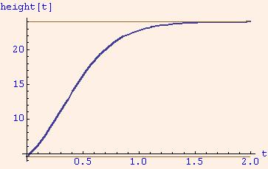

Looks OK.

Given that the typical mature Bernese Mountain Dog as described above weighs 85 pounds, give an approximate plot of the dog's weight as a function of time for the first three years and give a critique of the plot.

Answer: If you assume the dog maintains the same shape throughout the growing process, then you can say:
- weight[t] is proportional to the volume of the dog's body at time t and
- the volume of the dog's body at time t is proportional to height[t]^3. So
weight[t] = k (height[t])^3 =k ((b c e^(a t))/(b - c + c e^(a t)))^3.
The global scale of weight[t] is k ((b c e^(a t))/(c e^(a t)))^3=k b^3. For the typical Bernese Mountain Dog under study here, k is given by:

Solve[85==b^3 k,k]

The weight of the typical Bernese Mountain Dog under study here t years after her birth is:

Clear[weight];
weight[t_] = 0.00614873 height[t]^3

Here comes a plot:

weightplot = Plot[{weight[t],85},{t,0,2},PlotStyle->{{Thickness[0.01]},{Brown},{Brown}},PlotRange->All,AxesLabel->{"t","weight[t]"}]
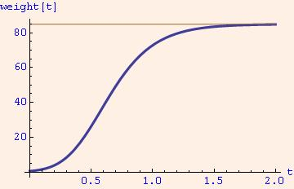

See the height plot and the weight plot side by side:

Show[GraphicsArray[{heightplot,weightplot}]]

Somewhat interesting.
Now comes the bad news: The dogs do not maintain the same shape throughout their growing years; they maintain only approximately the same shape as they grow.
The upshot: The weight plot should be regarded only as an approximation of the true story. One way to check it is to see what it predicts the birth weight of a Bernese Mountain Dog pup is:

weight[0]

In ounces:

weight[0] 16

Not bad. The typical birth weight of a Bernese Mountain Dog pup is 14 to 20 ounces. The approximation above is off, but not by very much.

T.3.c.ii) Here are plots of the instantaneous growth rates of the weight and height of the Bernese Mountain Dog.

Plot[{(weight′)[t],(height′[t]},{t,0,2},PlotStyle->{Thickness[0.01],Red},AxesLabel->{"t","Instantaneous growth rates"}]
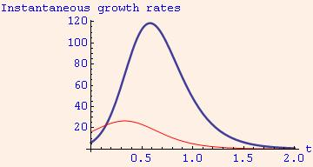

The height spurt happens before the weight spurt. This tells you that leggy adolescent animals are probably mathematical facts rather than anecdotal observations. Maybe someday someone will discover the mathematics of pimples.

Now look at plots of the instantaneous percentage growth rates of the weight and height of the Bernese Mountain Dog.

Plot[{(100 (weight′ [t])/weight[t],(100 (height′[t])/height[t]},{t,0,2},PlotRange->All,PlotStyle->{Thickness[0.01],Red},AxesLabel->{"t","Instantaneous percentage growth rates"}]
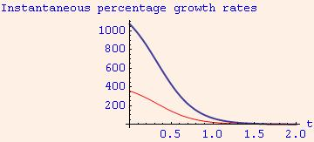

This plot looks a little suspicious.
It makes the strong suggestion that the instantaneous percentage growth rate of the weight is three times the instantaneous percentage growth rate of the height.
Is this an accident?

Answer: Get off it. In mathematics, there are no accidents.

Remember
weight[t]=k height[t]^3.
So by the chain rule
weight'[t]=3 k height[t]^2 height'[t].
Consequently, the instantaneous percentage growth rate of the weight is given by
100 (weight′ [t]/weight[t]
=100 (3 k height[t]^2 (height′ [t])/(k height[t]^3)
=3 100 (height′ [t]/height[t]
=3 (instantaneous percentage growth rate of the height).

The upshot: No matter what the height function is, the instantaneous percentage growth rate of the weight is three times the instantaneous percentage growth rate of the height.

A new piece of biological insight brought to you by the chain rule.
-----

In the Give it a Try section following the Tutorial, students are required to perform a similar analysis to model the height and weight functions of Haflinger horses. Using these functions they determine whether or not a Haflinger horse grows up before it grows out. Finally, the students are asked to do a similar analysis on themselves. As the students discover, they can produce their own height and weight functions knowing just four numbers: their height at birth, their height at maturity, the percent of mature height achieved at a given age, and their weight at maturity.

The final section of the lesson, the Literacy Sheets, consists of a list of problems to be completed by hand. The section starts with a list of twenty-five derivatives, eighteen of which require an application of the chain rule—sometimes in tandem with some other rule, like the product rule, quotient rule, or power rule. Other problems addressing the chain rule are conceptual, as illustrated by these two problems:

If Jenny does trig identities A times faster than Sam and Sam does trig identities B times faster than Cal, then Jenny does trig identities AB times faster than Cal. How is this little story related to the chain rule?

If $f\left(x\right)=sin⁡(g\left(x\right))$, then $f'\left(x\right)=cos(g\left(x\right))g^{'}(x)$. How do you know this is correct?

As already mentioned, students in BioCalc are asked to write explanations throughout the course.

Interested in Using the BioCalc Materials?
Because self-paced Mathematica notebooks (like the one outlined above) drive the BioCalc course, the course must be taught in a computer-equipped classroom. However, the necessary infrastructure is minimal. Computers need only to be capable of running Mathematica (see http://www.wolfram.com/support/).
To learn more about BioCalc and other Mathematica-driven courses offered at Illinois, see http://www-cm.math.uiuc.edu/. The reader interested in accessing the BioCalc materials should contact the NetMath Project Director at netmathinfo@cm.math.uiuc.edu.

In Memoriam: J. Jerry Uhl (1940 – 2010)

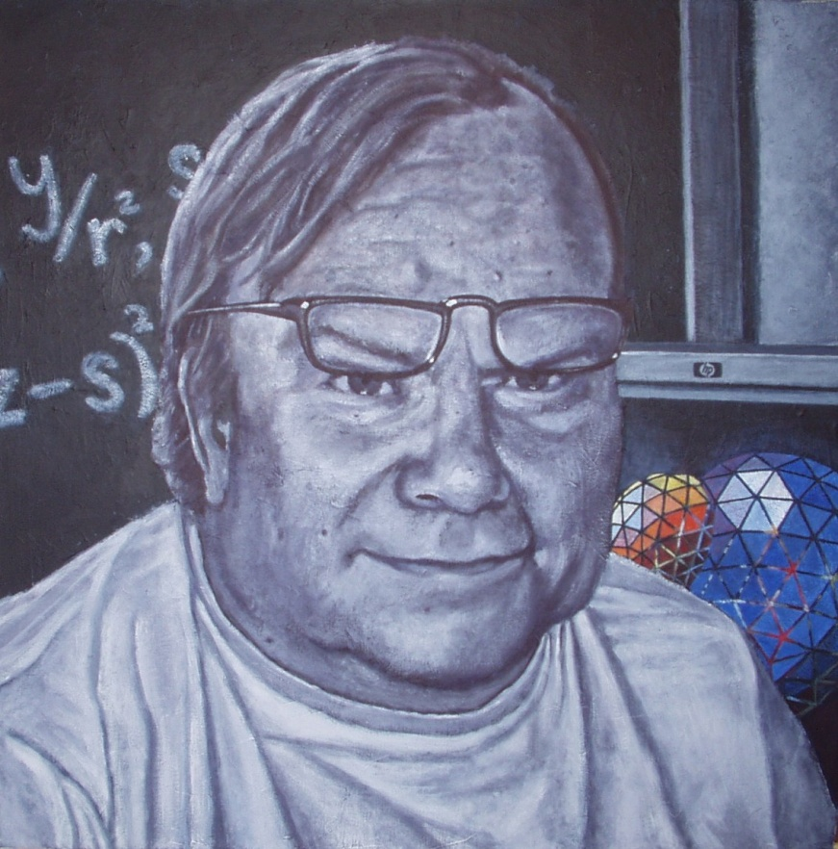

“Jerry” - painted by Judy Holdener in 2005. In the painting, Jerry is seated in front of his computer. The computer-generated surface represents Jerry’s belief that visualization plays a significant role in students’ understanding of mathematics.

A few words from the second author: Jerry passed away during the final revisions of this article. A beloved professor, mentor, and friend, he played a significant role in my development as a teacher. Besides revealing the importance of student-centered learning, he taught me to take risks in my teaching, and he continues to inspire me to be a transformational force for my students. I will miss his humor, his playfulness, his passion, and the mischievous and outspoken way in which he responded to bureaucratic nonsense.

References

Fahrbach, S., C. Washburn, and N. Lowery, 2001: The Impact of BioCalc on Life Sciences Undergraduates at UIUC, a report prepared for the Howard Hughes Medical Institute, 13 pp., University of Illinois\Kenyon College.

Uhl, J.J., W. Davis, and H. Porta, 2006: Calculus & Mathematica at UIUC, [available online at http://www-cm.math.uiuc.edu/].

holdenerj@kenyon.edu
This lab was funded by the Howard Hughes Medical Institute (HHMI).
CalcPrime is a three-week transitional summer program for entering students at Illinois who underperform on the placement exam for MATH 120. CalcPrime students have lower Math ACT scores than other BioCalc students, and they are more likely to be non-Caucasian-American.

