Tribolium Confusum Lab Protocol

Objectives
The objective of this lab is to study the population dynamics of the confused flour beetle, Tribolium confusum, a common household pest. Similar to the Crouse paper, this study will identify the crucial stages for management of this species. This will be done through experimentation and different treatments. Each lab group will be responsible for designing their own protocol for gathering the information necessary to create a mathematical model. The purpose of this lab is to give the math students exposure to how data is collected in a lab, while giving the biology students exposure to how mathematics can be used to gain insight into biological behaivor.

Introduction

The confused flour beetle, Tribolium confusum, is a common pest of stored grains. They can be found in flour, corn meal, dog food, cereals, and dried fruits (Borror et. al. 1981). However, Tribolium can also infest and destroy things such as stuffed bird and mammal study specimens. Since we have very valuable specimens of this sort in the biology museum, we’ll have to be especially careful not to let them loose in the lab.
This species has been used as the subject of many population and genetic studies in the laboratory, so lots of literature is available. In fact, one of your assignments will be to find five articles on the flour beetle and bring them to class (you should also use any the literature to inform your experimental protocol). We are going to give you a minimal amount of background information here. Each group will design its own experimental procedure.
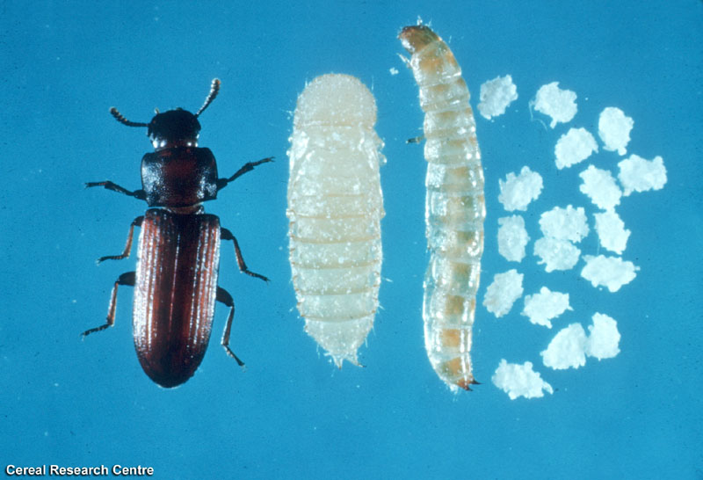
The life cycle of Tribolium confusum involves four distinctly different stages (as shown in Figure 1): egg, larva, pupae, and adult (Benoit et. al., 1998). A female adult flour beetle can lay from 300 to 500 eggs in a lifetime, and typically lays 2 to 3 eggs per day (Young, 1970). At 30° C, which is the temperature at which we will maintain the cultures, it takes an egg 5 to 7 days to hatch. Since it is an insect, Tribolium have an exoskeleton that has to be shed in order to grow. The larvae usually go through 6 to11 of these exoskeletons, before they are large enough to pupate. Each larval substage between the shedding of exoskeletons is called an instar. The shed exoskeletons can be found in the medium. The beetles usually remain in the larva stage for 2 to 3 weeks. The pupae do not move unless disturbed and do not feed. The pupa stage is about 8 days. Once a pupa becomes an adult, it spends three to four days in an immature, nonreproductive adult stage that is called the callow adult stage. After it reaches maturity, the beetle can live for as long as one to two years (Park et al 1965).
Figure 1: The four distinct stage of Tribolium confusum
One other thing to consider: the larva and adult beetles are cannibalistic. The larva will eat the eggs, pupae, and callow adults. The adults will eat everything except for other mature adults. There is a large amount of literature concerning cannibalism, if you are interested in trying to determine its effects. Cannibalism increases with density (Benoit et. al., 1998).

Lab Procedure

Each of your Tribolium cultures should be kept in a medium of four parts whole wheat flour and one part brewer’s yeast. The whole wheat flour has all been sieved through a 149 μm sieve to remove all of the large particles in the flour. These cultures will be maintained at 30ºC to maximize growth rate. Each of the distinct life stages are delicate and must be handled carefully. Before setting up any cultures, familiarize yourself with each stage so you are confident in your ability to find each one. The best way to do this is to use the sieves provided. All large larva, adults, and some of the pupa will be caught in the no. 35 sieve (500μm). All the eggs, pupa and small larvae should be caught in the no. 60 sieve (250μm), so this is the smallest sieve you will want to use.

Eggs
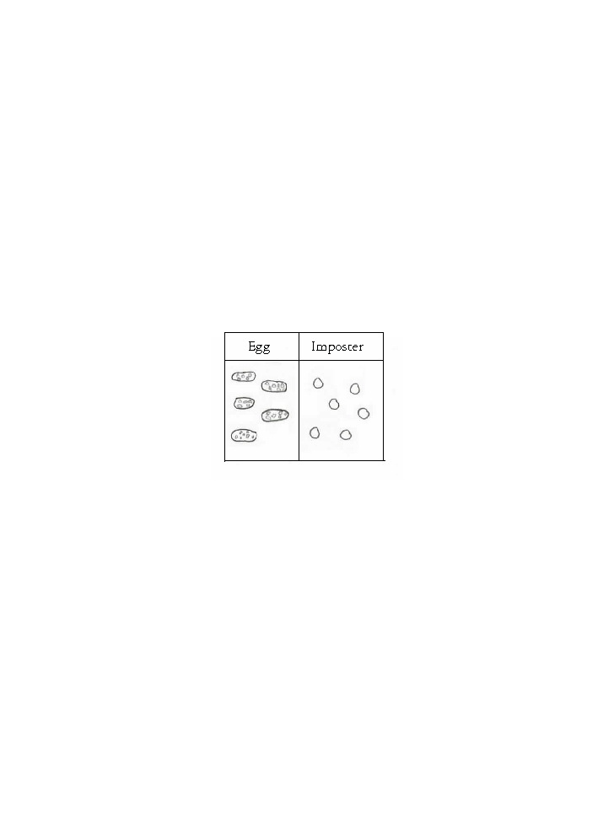
Tribolium eggs are very small and are almost impossible to find without the use of a dissecting microscope. However, with a microscope under 40x magnification, you can tell the eggs apart from everything else because they will be one of the biggest things in the medium (as long as the flour has been sieved). The eggs are all white in color, oblong in shape, and typically coated with flour. The yeast can be confused with eggs, however, because it is approximately the same size as the eggs. You tell the yeast apart from the eggs by color and shape. The yeast is more opaque in color and tends to be perfectly spherical. Figure 2 gives an idea of what the eggs look like in comparison to the yeast. Wheat particles in the flour can also be confused with the eggs. These are often coated in flour, and are approximately the same size as the eggs. The only way to tell the eggs apart from the wheat particles is to examine them both very carefully. Under the flour, the eggs will always be white while the wheat particles are light brown or tan. Do not use insect forceps to collect the eggs from the sieve. Instead, make an aspirator using a glass “shell vial,” a rubber stopper with two holes, and two lengths of rubber tubing (see Figure 3). Use the aspirator for collecting both eggs and young larva.
Figure 2: The difference between an egg and the yeast seen at 40x magnification
Figure 2: The difference between an egg and the imposter seen at 40x magnification. The little dots on the eggs are flour pieces.

Larva
Handling Tribolium larvae is different than handling the eggs. Unlike the eggs, the larvae are easy to distinguish from their surroundings, provided you can find them. Larvae typically go through 6 to 11 instars (moltings) before maturing to pupae. Immediately after hatching, they are so small that they are difficult to find, even with a microscope. Also, the young larva tend to get caught in the mesh of the sieve, so be sure to check the grates when sieving. The larvae are white and range in size from approximately 1mm in length to just over 7mm when they are in their final instar. Young larva are easiest to handle with the aspirator, but older larva can be handled, albeit carefully, with insect forceps.

tubing
tip

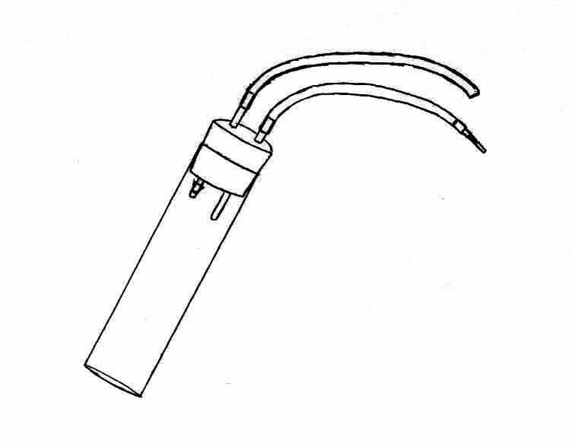

Rubber stopper
Tubing
Tip

Pupa
This is the easiest stage to deal with. The pupae are pale yellow to tan in color and appear to be crusted over. Tribolium pupae are approximately 5 mm long. Since they are pupating, they do not move unless they are prodded gently with insect forceps, which will cause them to wiggle around a bit. This is the best way to determine if they are alive, by the way. The pupa is the first stage in the life cycle that can be sexed. To sex the pupae, flip them on their ventral side (so you can see the outline of where the wings will be) and examine the terminal segments. Figure 4 shows the difference between male and female terminal segments.
Figure 3: Diagram of an aspirator
shell vial

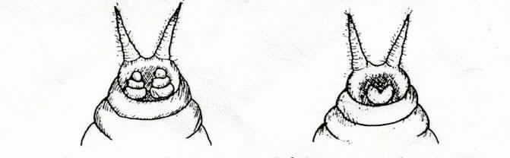
Figure 4: Terminal segments of flour beetle pupae. Left, female; Right, male

Adults
Adult Tribolium go through two phases. Immediately after emerging from the pupal stage, adults are callow (i.e. unreproductive) and are a pale yellow color. After a few days, the adults darken in color to a dark reddish-brown and are able to reproduce. The easiest ways to handle the adults is with the insect forceps or by letting them crawl onto a small piece of paper. The adult stage can also be sexed. The easiest way to do this is to place a petri dish with adults on top of a bed of ice. The cold will cause the adults to stop moving, making them easier to handle. Lay the adult on its dorsal side (on its back), and gently squeeze the abdomen with a pair of insect forceps. This will evert the genitalia, which are distinct on females and males (see Figure 5). Be careful not to squeeze too tightly or you will injure or kill the adult. As long as you are gentle, the genitalia will retract and the beetle will be fine.



